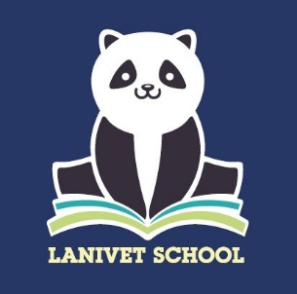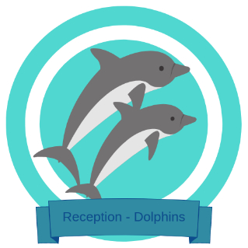

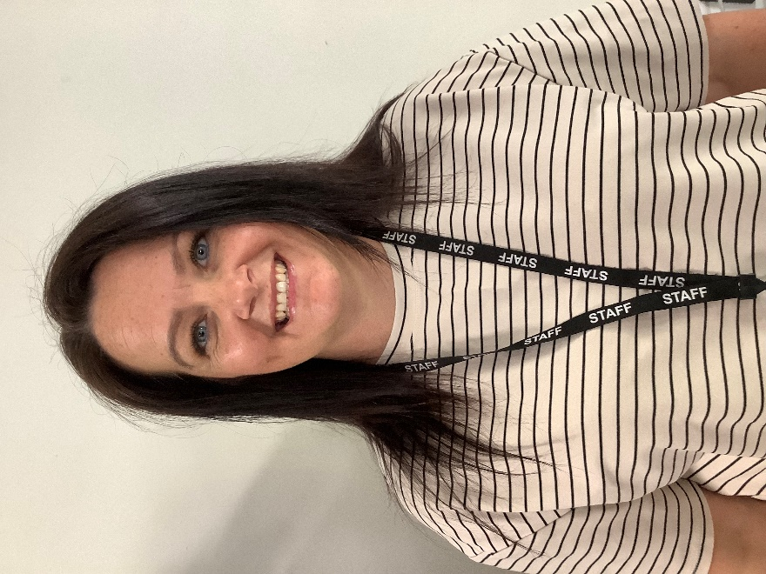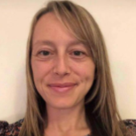Welcome to Dolphins – Reception Class!

Hello. My name is **Miss Smallman** and I am one of the teaching assistants in Reception Class. I have recently joined Lanivet School and looking forward to meeting the new reception class. I have previously worked with reception children in a variety of different schools. I am enthusiastic about supporting and helping pupils to grow in their first year of school. Providing lots of support and care. I enjoy helping pupils reach their potential at their own pace and level.

I really enjoy spending time with my three boys walking the dog and enjoying the outside. I enjoy new experiences and especially enjoy a good trip to the theatre. My favourite children's book is ‘the BFG’ because it is great fun but also teaches people not to judge people by their appearance. I am looking forward to spending the year with you all.

Hello. My name is **Mrs Hunt** and I am one of the teaching assistants in Reception Class. I have worked in early years for many years and I have an NVQ Level 3 Early Years Child Care Educator and an NVQ Level 3 Diploma in Forest School. I have a real passion for Early Years and enjoy making the classroom a welcoming, exciting, and happy place in which the children can learn, thrive, and grow.

I really enjoy spending time with my youngest daughter who is about to transition to secondary school and spending time with my slightly older twins. I enjoy being outside, going for cycles and camping with the whole family including our pet dog. My favourite children's books are the large family collection which includes stories such as ‘5 Minutes Peace’ and ‘A Piece of Cake’. I can't wait to meet you all soon; it's going to be an exciting year!

Hello. My name is **Ms. Bowden** and I am the teacher in Reception Class.

I joined the team at Lanivet in 2021, after teaching at another local primary school for 5 years. I am passionate about creating a fun, safe and engaging learning environment whilst encouraging pupils to develop their independence. I enjoy sharing my love for learning with the children using a cross curricular approach.

When I’m not at school I enjoy spending time with my own young children, spending lots of time outdoors exploring and going on coastal walks. My family and I particularly enjoy snuggling together and reading a good book. We all love the Julia Donaldson books, rhyming books and funny books written by David Walliams. As a family, we enjoy sharing the stories we have read and recommending recent books to others so that they can also enjoy the exciting written adventures. I hope you love reading as much as I do.

