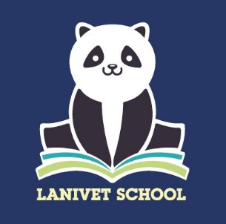

Welcome to Dolphins – Reception Class!

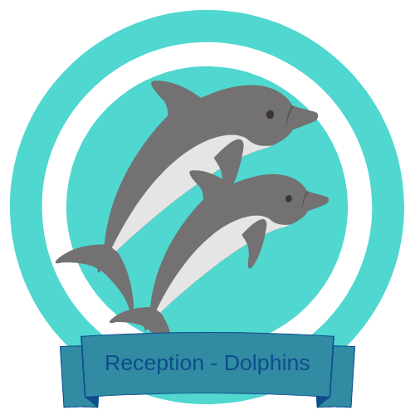

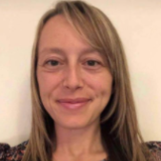

Hello. My name is **Ms. Bowden** and I am the teacher in Reception Class.

I joined the team at Lanivet in 2021, after teaching at another local primary school for 5 years. I am passionate about creating a fun, safe and engaging learning environment whilst encouraging pupils to develop their independence. I enjoy sharing my love for learning with the children using a cross curricular approach.

When I’m not at school I enjoy spending time with my own young children, spending lots of time outdoors exploring and going on coastal walks. My family and I particularly enjoy snuggling together and reading a good book. We all love the Julia Donaldson books, rhyming books and funny books written by David Walliams. As a family, we enjoy sharing the stories we have read and recommending recent books to others so that they can also enjoy the exciting written adventures. I hope you love reading as much as I do.

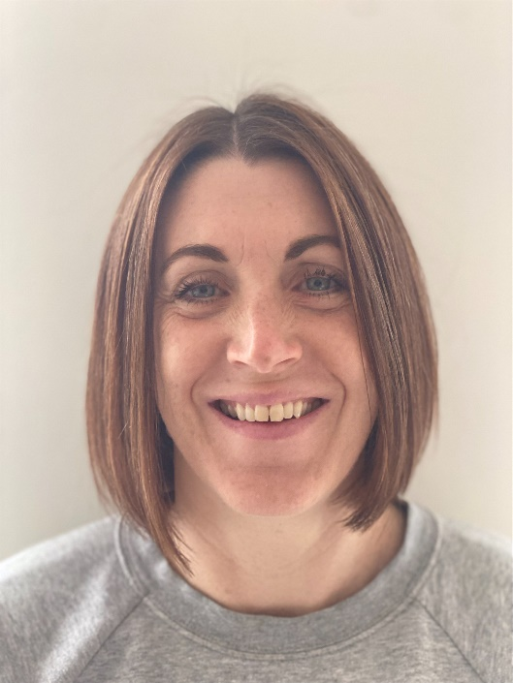

Hello. My name is **Mrs Facer** and I am the teaching assistant in Reception Class.

I have worked at Lanivet School for nearly 6 years and have an NVQ Level 3 Early Years Educator and an NVQ Level 3 Diploma Supporting Teaching and Learning in Schools. I have a real passion for Early Years and enjoy making the classroom a welcoming, exciting, and happy place in which the children can learn, thrive, and grow.

I really enjoy coastal walks with my family at the weekends and love reading books. My favourite children's book is 'Oi Frog' because it always makes me laugh! I can't wait to meet you all soon; it's going to be an exciting year!