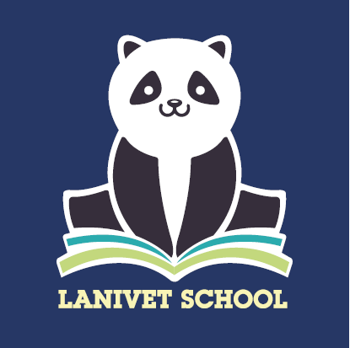Lanivet School

Honey’s Hill, Lanivet

Bodmin, PL30 5HE

Headteacher – Mr T. Gray

Telephone: 01208-831417

[www.lanivet.cornwall.sch.uk](http://www.lanivet.cornwall.sch.uk)

**Pupil Premium and Free School Meals**

Since April 2011 we have received Pupil Premium in addition to our main school funding. The school receives funding for three groups of children;

* Children currently receiving free school meals (FSM) or having received them within the last six years (Ever 6)
* Children whose parents are in the services,
* Children who are in Local Authority Care (CiC) or who have been adopted.

With infants receiving Universal Free School Meals there may appear no reason to apply even if eligible. However, if your child is entitled to a free school meal please do register even if you have no intention of using this facility. Your child and the children of Lanivet School will benefit from additional opportunities as a result and this funding will continue for 6 years after FSM ends.

Details on how to apply and support in making your application for Free School Meals can be accessed by the link below to Cornwall Council's website:

<https://www.cornwall.gov.uk/schools-and-education/schools-and-colleges/school-meals/apply-for-free-school-meals-and-pupil-premium/>

The Pupil Premium funding is not spent as a specific amount per child. Spending is decided on a needs basis and allocated accordingly. It is not possible to say how a budget is used specifically for each individual child. For more information on how Lanivet School use the Pupil Premium Funding please see the link below:

<https://www.lanivet.cornwall.sch.uk/web/pupil_premium/618443>

Thank you for your continued support.

Kind regards,

Lanivet CP School