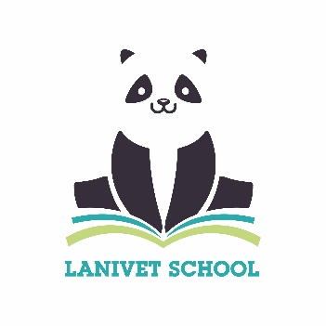 | Lanivet School  Uniform Requirements

The wearing of school sweatshirts is actively encouraged as it promotes a sense of unity and belonging. Please ensure that all items of clothing are clearly named.
School Uniform | White or royal blue polo shirts  Royal blue sweatshirts/jumpers/cardigans  Grey or black tailored shorts/trousers  Grey or black skirts or pinafore dresses  Light blue gingham check summer dresses
Footwear | Plain black or navy low heeled school shoes or black trainers
PE Clothing | Plain black or royal blue shorts or gym skirts plain white or royal blue t-shirt (except for house matches)  Plimsolls or another pair of black or white trainers separate from above during cold weather a track-suit may be worn (not bright colours)
Forest School Clothing | Full set of waterproofs (puddle suit)  Wellie boots (which will stay in school)  Sun hat for (for summer)  Hat, gloves and scarf (for winter)

Jumpers, polo shirts and PE shirts embroidered with the school logo are available from Wovina in Bodmin. You can order on-line here: https://www.wovina.com/collections/lanivet-school-73-c
Lanivet School book bags/reading packs can be ordered online here: https://www.wovina.com/collections/lanivet-school-73-c
Embroidered tops/jumpers are not essential, plain school uniform tops that can be bought from any of the main supermarkets are acceptable.
Jewellery & Valuables
Jewellery, nose or eyebrow studs should not be worn. If earrings are essential, they must be limited to one pair of plain studs. Children should not bring toys, mobile phones or other valuable items into school unless specifically instructed by staff. No cash is required in school, as we are a cashless school.
Hair
Shoulder length hair and longer should be worn tied back with suitable hair bands at all times. Hair should be in natural shades only and worn in a conventional style.
We want to work with you to ensure the pupils of Lanivet School look as smart as they can.
Thank you for your support with this school uniform policy.

